Software Testing (CS 4036)
Date: 23rd February, 2026
Course Instructor(s):
Mr. M. Waqas, Mr. Usman Aamer

Sessional-I Exam
Total Time (Hrs): | 1
Total Marks: | 35
Total Questions: | 3

___________ __________ _____________________
Roll No Section Student Signature

Answer all questions. Answer questions in the same order as they appear on question paper. Answer all questions on answer sheets.

Question1: Given is the code and its Control Flow Graph [3+7]

int computerFine (int daysLate[], int numDVD, boolean printOn)  {  1 int MAX_FINE_PERIOD = 21, int cumFine = 0;  2 for (i=0; i<numDVD; i++) {  3 fine=MAX_FINE;  4 if (daysLate[i]<=MAX_FINE_PERIOD) {  5 fine=daysLate[i] * DAILY_FINE;  }  6 logFine (fine);  7 if (printON == TRUE) {  8 printFine(fine);  }  9 cumFine += fine;  }  10 return cumFine;  } | 1  2  3  4  5  6  7  9  8  10  T  F  T  F  T  F

1. Calculate Cyclomatic Complexity and show the method.
2. List all paths which provide statement, branch and condition coverage.

Question 2: Data Flow Testing [8+2+5]
1 int main()  2 {  3 int a, b, t;  4 cout << "Enter first number: ";  5 cin >> a;  6 cout << "Enter second number: ";  7 cin >> b;  8 if (a < b) {  9 t = a;  10 a = b;  11 b = t;  12 }  13 cout << a << " " << b << endl;  14 return 0;  15 } | Consider a program to input two numbers and print them in ascending order given below.  - Provide all du-paths, all-uses and all-definitions  - Identify those du-paths that are definition clear.  - Provide test cases for all paths in point1.

Solution:

All du-Paths
Variable | Definition at Line | Use at Line | Path (Nodes/Lines)
a | 5 | 8 | (5, 6, 7, 8)
a | 5 | 9 | (5, 6, 7, 8, 9)
a | 5 | 13 | (5, 6, 7, 8, 12, 13) — Condition False path
a | 5 | 13 | (5, 6, 7, 8, 9, 10, 11, 12, 13)— Condition True path
a | 10 | 13 | (10, 11, 12, 13)
b | 7 | 8 | (7, 8)
b | 7 | 10 | (7, 8, 9, 10)
b | 7 | 13 | (7, 8, 12, 13) — Condition False path
b | 7 | 13 | (7, 8, 9, 10, 11, 12, 13) — Condition True path
b | 11 | 13 | (11, 12, 13)
t | 9 | 11 | (9, 10, 11)

All uses
Variable | Definition at Line | Use at Line | Path (Nodes/Lines)
a | 5 | 8 | (5, 6, 7, 8)
a | 5 | 9 | (5, 6, 7, 8, 9)
a | 5 | 13 | (5, 6, 7, 8, 12, 13) — Condition False path
a | 5 | 13 | (5, 6, 7, 8, 9, 10, 11, 12, 13)— Condition True path
a | 10 | 13 | (10, 11, 12, 13)
b | 7 | 8 | (7, 8)
b | 7 | 10 | (7, 8, 9, 10)
b | 7 | 13 | (7, 8, 12, 13) — Condition False path
b | 7 | 13 | (7, 8, 9, 10, 11, 12, 13) — Condition True path
b | 11 | 13 | (11, 12, 13)
t | 9 | 11 | (9, 10, 11)

All-definitions
Variable | Definition at Line | Use at Line | Path (Nodes/Lines)
a | 5 | 8 | (5, 6, 7, 8)
a | 5 | 9 | (5, 6, 7, 8, 9)
a | 5 | 13 | (5, 6, 7, 8, 12, 13) — Condition False path
a | 5 | 13 | (5, 6, 7, 8, 9, 10, 11, 12, 13)— Condition True path
a | 10 | 13 | (10, 11, 12, 13)
b | 7 | 8 | (7, 8)
b | 7 | 10 | (7, 8, 9, 10)
b | 7 | 13 | (7, 8, 12, 13) — Condition False path
b | 7 | 13 | (7, 8, 9, 10, 11, 12, 13) — Condition True path
b | 11 | 13 | (11, 12, 13)
t | 9 | 11 | (9, 10, 11)

Question 3: You are provided with a set of requirements for a new software feature. Using the XP Test-First Process (as defined by IEEE 2005), document your development steps. For each iteration, you must clearly state the failing test, the production code logic implemented, and any refactoring performed. [3x3+1]
Following is the test-first process in XP (extreme programming).  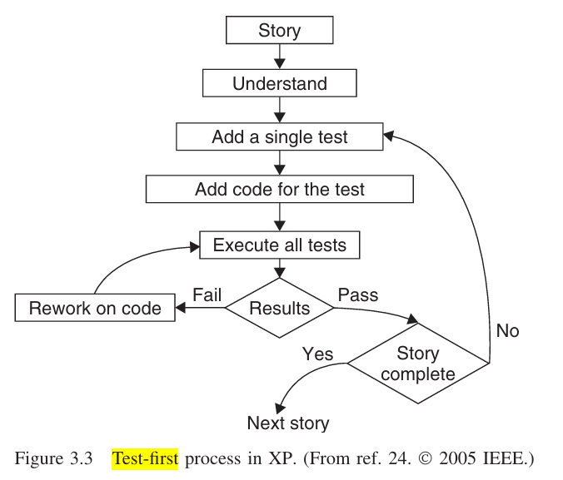 | The Scenario: "Loyalty Points Calculator"  A retail company needs a module to calculate "Loyalty Points" earned by customers during a purchase. The requirements are as follows:  - Base Points: Customers earn 1 point for every $10 spent.  - Rounding: Points are only awarded for whole increments of $10 (e.g., $19.99 still earns only 1 point).  - Bonus Tier: If a single purchase exceeds $100, the customer earns double points on the entire amount (e.g., $110 earns 22 points instead of 11).

Solution:

Iteration 1: Implementing Base Points
1. The Failing Test (Red)
We write a test for a basic purchase that should result in 1 point.
- Input: 10.00$
- Expected Output: 1$
- Status: FAIL (Function calculatePoints does not exist yet).
2. Production Code Logic (Green)
We implement the bare minimum to make the test pass.
Python
def calculatePoints(amount):
return amount / 10
3. Refactoring
No refactoring is needed at this stage as the logic is a single line.

Iteration 2: Handling Rounding Constraints
1. The Failing Test (Red)
We test the requirement that points are only awarded for whole increments of 10$.
- Input: 19.99
- Expected Output: 1$
- Status: FAIL (Current code returns 1.999$).
2. Production Code Logic (Green)
Update the logic to ensure we only count complete 10$ units.
Python

def calculatePoints(amount):
# Use floor division or cast to int to handle whole increments
return int(amount // 10)
3. Refactoring
We move the constant 10 to a variable named POINTS_THRESHOLD to improve readability and maintainability.

Iteration 3: Implementing the Bonus Tier
1. The Failing Test (Red)
We test the bonus logic where purchases exceeding 100$ earn double points on the entire amount.
- Input: 110.00$
- Expected Output: 22$ (Base points: $11 X 2$ bonus multiplier)
- Status: FAIL (Current code returns 11$).
2. Production Code Logic (Green)
Add the conditional logic for the bonus tier.
Python
def calculatePoints(amount):
base_points = int(amount // 10)
if amount > 100:
return base_points * 2
return base_points
3. Refactoring
To make the code "cleaner" and more extensible, we can separate the multiplier logic into a descriptive variable.
Python
def calculatePoints(amount):
POINTS_THRESHOLD = 10
BONUS_THRESHOLD = 100

base_points = int(amount // POINTS_THRESHOLD)
multiplier = 2 if amount > BONUS_THRESHOLD else 1

return base_points * multiplier

Iteration | Requirement | Input | Expected | Resulting Logic
1 | Base Points | 10$ | 1$ | points = amount / 10
2 | Rounding | 19.99$ | 1$ | points = amount / 10
3 | Bonus Tier | 110$ | 22$ | if amount > 100: points /x 2

